September 2025

Year 1 Newsletter





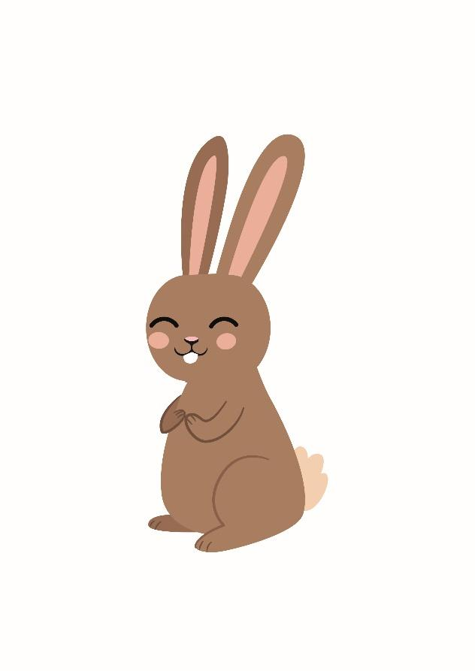

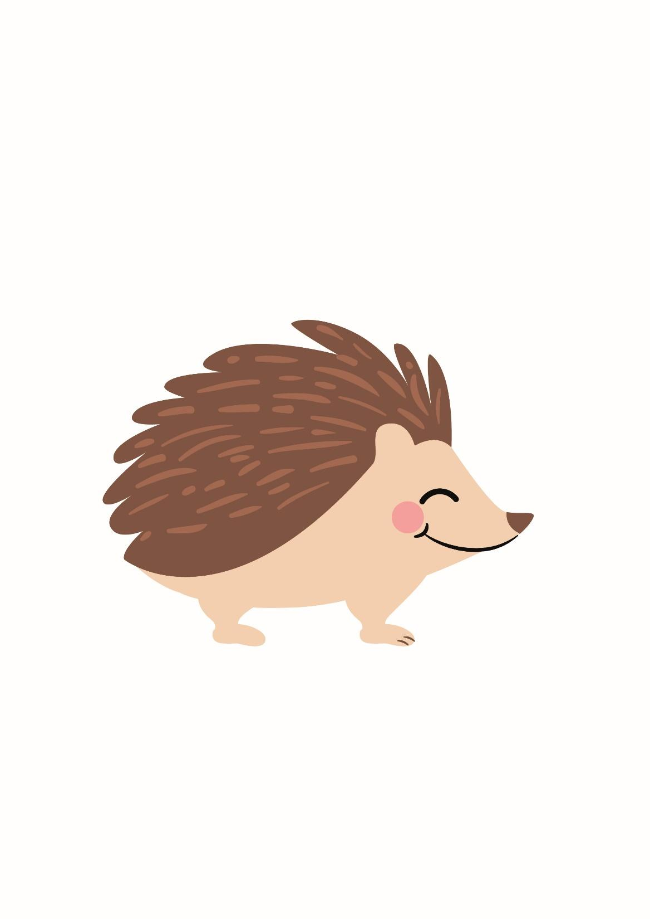

Welcome to Year 1

**Staffing**

In 1H, rabbit class, Miss Hardwick is the class teacher. Other adults in the class providing support are Mrs Booth, Mrs Thornton, Miss Beel, Miss Dixon, Miss Maginnis and Miss Hardie. Mrs Connolly will teach the class every Tuesday morning. In 1GC, hedgehog class, Mrs Connolly will teach the class on a Monday and Mrs Galbraith will teach them the rest of the week. Other adults in the class providing support are Mrs Jones, Mrs Paine, Mrs Dickinson and Miss Dixon.

On Friday afternoons the children will be working in small groups with different members of staff. They will do lots of exciting activities including RE, music, cooking, computing and nature walks. Please could your child bring a pair of named wellington boots to leave in school ready for their nature walks.

**Morning and Home time**

Our doors open at 8.45am in the morning, and we finish at 3:15 in the afternoon. Please bear with us at home time; we will get quicker once we get to know you all!

**Curriculum**

Our first topics are ‘All About Me’ and ‘Autumn and Harvest’. We have lots of exciting learning planned. As part of our history lessons we will be looking at how we have changed. We would like everyone to bring in one named baby/toddler photo to help with these discussions if possible please. Alternatively, you can email the picture and we will print them in school.

**Reading**

We are busy hearing all the children read individually. In their book bag, they will have a reading book and a new reading record. Please read with your child at least **four** times a week and write in the reading record so we know what they have read. Please keep the reading book and record in your child’s book bag during the week as we can never predict on which day of the week we will read with them. We will change the children’s home reading books every **Friday**.

**New Phonic Scheme**

We are holding an information meeting on **Wednesday 17th September** at **5pm** to explain our new phonic scheme ‘Essential Letters and Sounds’. The session will take place in the Year 1 classrooms. It is just for adults, so children don’t need to attend. More details to follow.

**Library**

As well as the home reading books, we have a good selection of library books for children to borrow and enjoy at home. Your child will choose their own book to share with you at home. Our library day is **Friday**.

**PE**

In Year 1 the children participate in PE sessions twice a week. We will be doing PE every **Monday** and **Thursday**. Please make sure that your child wears their PE kit to school. If the weather is fine, we will do one of our PE sessions outside. Please make sure that they have appropriate footwear. Please remember to label all their clothing so that items don’t get lost!

**Homework and Spelling Books**

Your child will bring home their homework book in the next few weeks. In the book there will be a short task for your child to complete with an adult at home. On the alternate week a spelling book will be sent home. It will have a spelling pattern for your child to investigate e.g. ‘ee’ to make words such as ‘feet’ or key words to learn. This is to help your child to develop their understanding of spelling and practise their cursive letter formation. There will not be a spelling test.

**Visits and Visitors**

Throughout the year, to enhance the children’s learning and to gain first hand experiences, we will arrange for trips out of school as well as workshops run by visitors in school. A lot of these will be free, however, some will require a contribution. Please see the table below for the main visits and events in Year 1 this year:

|  |  |  |
| --- | --- | --- |
| Date | Visit or Event | Approximate cost |
| 1GC – Tuesday 18th November  1H - Thursday 20th November | Great Fire of London Workshop at Temple Newsam  Visit to St John’s Church - Date TBC | £5.00  Free |
| 1GC – Tuesday 13th January  1H – Thursday 15th January | Visit to Cartwright Hall Art Gallery | £2.00 |
| Friday 13th February | Year 1 Art Gallery – Everyone is invited to see their amazing work after school at our art gallery in the school hall | Free |
| June/July – Date TBC | Rodley Nature Reserve  Animal Workshop in school – Date TBC | Voluntary Donation  £4.00 |

We will send home more detailed letters about each event. We may need parent volunteers to help us with our visits out of school.

**Year 1 News**

Every **Friday,** we will update the Year 1 blog and inform you what your child has been learning about. We will also regularly post photographs and write about all the exciting things we do in Year 1.

Our blog can be found on the school website [www.farsleyfarfield.org.uk](http://www.farsleyfarfield.org.uk). Just click on the menu and then click blogs and find the ‘Year 1 News’ page. If you have registered your email address, you will get a notification of a new blog post from us every Friday.

We hope that your child will have lots of fun in Year 1. If you have any concerns, please either talk to any of the staff in the class or you can email us on: [alexandra.galbraith@farsleyfarfield.org.uk](mailto:alexandra.galbraith@farsleyfarfield.org.uk) , [vicki.connolly@farsleyfarfield.org.uk](mailto:vicki.connolly@farsleyfarfield.org.uk) or [jessica.hardwick@farsleyfarfield.org.uk](mailto:jessica.hardwick@farsleyfarfield.org.uk)

The Year 1 Team