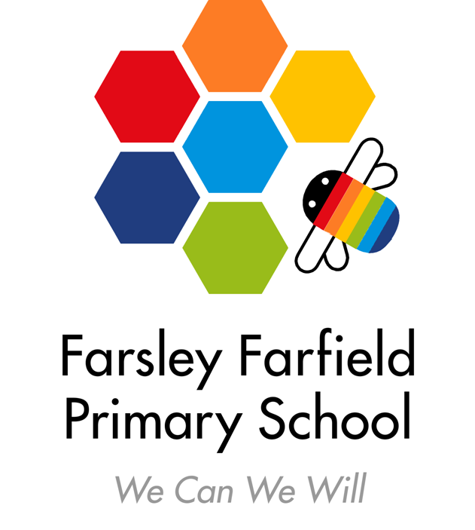

Farsley Farfield Primary School

Cote Lane, Farsley, Leeds LS28 5ED

**Infants:** Telephone 0113 2058133

**Juniors:** Telephone: 0113 2058130

E-mail: [office@farsleyfarfield.org.uk](mailto:office@farsleyfarfield.org.uk)

# 23rd May 2025

Dear Parent/Carer,

To support our science topic, Year 1 are planning a trip to Rodley Nature Reserve.

**1T** will be going on **Tuesday 10th June** *(we expect Eid celebrations for most families will have been completed by this date. If this is a problem, any children missing the trip could be included on the Thursday.)*

**1B** will be going on **Thursday 12th June**

We will be travelling on the school minibuses. The children will need a packed lunch. They will also need a rucksack or bag so that they can carry their own lunch and drink. If your child qualifies for free school meals (not through the Universal Infant Free School Meal credit that everyone gets), then school can provide a packed lunch if requested on the slip below. Children can come to school in non-uniform, ideally leggings or tracksuit bottoms. We will be outside all day. Please ensure that your child is wearing appropriate footwear and a raincoat or sun hat/sun cream depending on the weather forecast.

There is no charge for this trip but your child is encouraged to put a donation in the collection box at the reserve if possible.

We need some parent helpers to go with us please.  If you are able to come, please let us know.  Unfortunately, parent helpers will need to provide their own transport or share a car with another adult as we do not have enough space on the minibuses.

Please return the below slip by **Friday 6th June**.

Yours faithfully,

The Year 1 Team

**Year 1 trip to Rodley Nature Reserve**

I give permission for ____________________________Class ______ to go on the trip to Rodley Nature Reserve.

I am / am not able to help on the trip if required (please delete as appropriate)

Please note - we will confirm which volunteers we need as soon as possible.



Please tick the box if you are happy to drive other adults in your car.

My child is eligible for free school meals (not UIFSM) and I would like school to provide a 

packed lunch.

# Signed: __________________________________________ Parent/Carer