Newsletter for Primary Schools

January 2019 – Issue 3

Hello friends,

I hope you all return to a new term, and a new decade, feeling hopeful and positive about the future, both in your personal and work lives. I wish a Happy 2020 to you all.
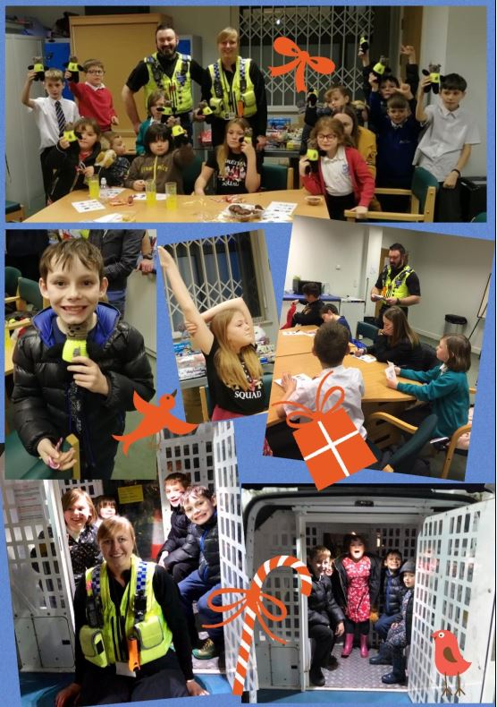
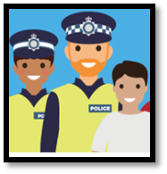
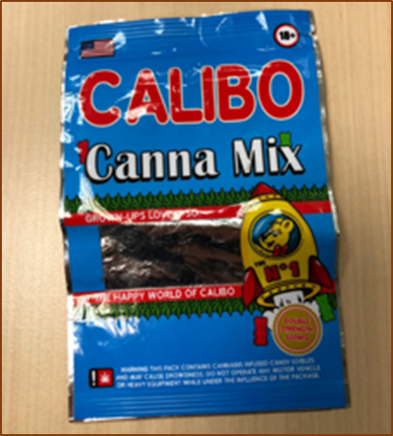

Christmas themed Safety Talk given to children at the ECHO project – Dec 2019

PCSO’s Newell and Riley had the pleasure of attending at the ECHO (Every Child Has Options) community group in Knottingley, after being asked to attend to give the children a talk on safety.

During their visit Aaron and Claire spoke about their role within the police and the great variety that their job as a PCSO has to offer. They then played an interactive game of, ‘Police Safety Picture Bingo’, before allowing the children to explore inside the police van and operate the lights & siren. At the end of the talk the children were given some goodies that had been kindly donated to them following on from the ‘Knottingley Christmas Walk’ event. They were also each given a very special police bear as a Christmas present which had been lovingly knitted by Claire’s Grandma. A very big Thank You to her for taking the time to do that!

Pictured here we have some of the highlights from their visit, in which they said to have loved ❤️every minute of!

They were also each given a very special police bear as a Christmas present which had been lovingly knitted by Claire’s Grandma. A very big Thank You to her for taking the time to do that!

Engaging with school children across West Yorkshire
Cannabis Edibles
This pack of ‘sweets’ was found at a high school in West Yorkshire. They are likely to contain cannabis (THC) which is a Class B drug.
If you find a child with these, please report this to our drugs coordinator, Jess Clayton, (07719418068) for further advice.
- Remove the sweets and save them for testing by WYP, and establish where they were purchased, if possible

- Educate children that there may be dangerous substances in them which could make them feel unwell.

Young Minds 360 - Resources, Lesson Plans and Tips for Building a Culture of Positivity
If you’re not familiar with Young Minds 360, their website is well worth a look. There are lots of free resources to support positive mental health, wellbeing and resilience.
I have attached the activity below, and one other, to this email, as an example of what’s available.

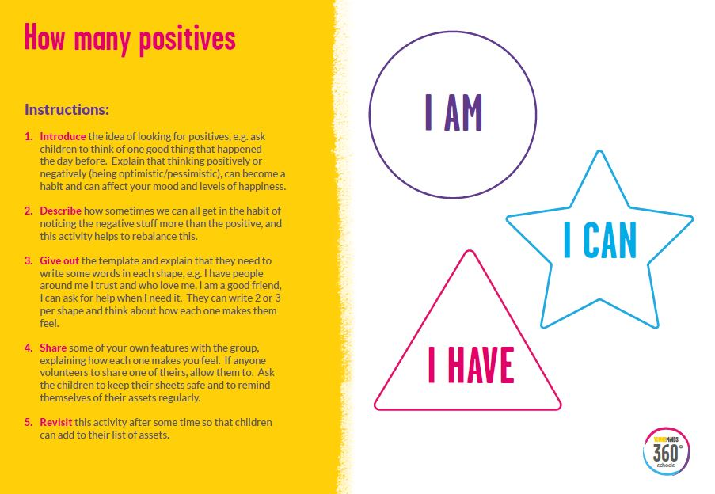

------------------------------------------------------------------------------------------------------------------------------------
*If you wish to be removed from this circulation list, just let me know, or equally, if you would like to receive it directly, I’d be happy to add you!
Sarah Whitehead - Education Liaison Officer – Local Policing
Email – sarah.whitehead@westyorkshire.pnn.police.uk Twitter – WYP_ChildrenYP

