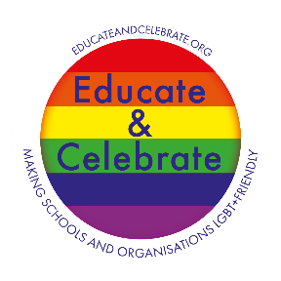

**In partnership with Educate and Celebrate the Health and Wellbeing Service Presents:**

**A whole school approach to LGBT+ Inclusion**

**Wednesday 28th November 2018**

**9.15am – 3.30pm**

**North East Learning Centre**

**Talbot Avenue, Leeds, LS17 6SF**

**Outline:**

This interactive training led by Dr Elly Barnes (Educate and Celebrate) will support you to achieve LGBT+ Inclusion, developing subject knowledge and strategies to take a whole-school approach to creating institutional change by focusing on the core areas of Training, Policy, Curriculum, Environment and Community.

**Course overview:**

The practical and teacher-friendly training is designed to give you the confidence to lead the initiative within your own school, underpinned by relevant reading books at all key stages, research materials, lesson plans in all subject areas, key messages via display, sing-a-long songs, teaching pedagogies, impact day activities, exemplar policies and an action plan to take forward and start delivering the very next day!

This course aims to:

* provide participants with increased LGBT+ knowledge
* develop a deeper understanding of sexual orientation and gender identity and why it is necessary to include these in the curriculum
* provide participants with an understanding of the law in relation to LGBT and OFSTED criteria/expectations
* provide participants with lesson plans, resources and examples of environmental change and good practice
* enable participants to create an action plan for a whole school approach to LGBT + Inclusion

**Bookings and enquires**

To book a place on the course please visit: <https://secure2.sla-online.co.uk/Training/mTrainingDetails.aspx?id=76631>

For further information on the course please contact: Sheryll Carter [sheryll.carter@leeds.gov.uk](mailto:sheryll.carter@leeds.gov.uk)