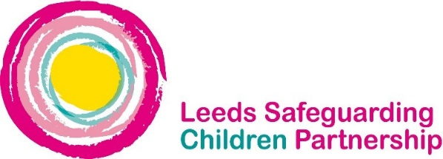

FGM – International Zero Tolerance of FGM – 6th February
Key messages:
What is FGM?
Female Genital Mutilation (FGM) refers to procedures that intentionally alter, mutilate or cause injury to the female genital organs for non-medical reasons. FGM is medically unnecessary and can have serious health consequences, both at the time it is carried out and in later life. FGM is illegal in the UK. It is child abuse and a criminal offence.
FGM is deeply embedded in some communities and is performed for cultural and social reasons. It is usually carried out on girls before they reach puberty, but in some cases it is performed on new-born infants or on women before marriage or pregnancy. FGM is an extremely harmful practice which violates basic human rights.

Risk Factors
The most significant risk factor for girls and young women is coming from a community where FGM is known to be practised and/or where a mother, sister or other female family member has been subjected to FGM.
The procedure may be carried out when the girl is newborn, during childhood or adolescence, at marriage or during the first pregnancy. However, the majority of cases of FGM are thought to take place between the ages of 5 and 8 and therefore girls within that age bracket are at a higher risk.

Girls of school age who are subjected to FGM overseas are thought to be taken abroad at the start of the school holidays, particularly in the summer holidays, in order for there to be sufficient time for her to recover before returning to her studies.

Leeds Referral Pathway for Practitioners
If practitioners are aware, or suspect that a child or young person has undergone, or may be undergoing the procedure they should follow the West Yorkshire procedures and the Leeds Referral Pathway.

Regulated professionals in health and social care professionals and teachers in England and Wales have a duty to report 'known' cases of FGM in under 18s which they identify in the course of their professional work to the police.

Practitioners should complete the West Yorkshire Police FGM Reporting Form and email to cib@westyorkshire.pnn.police.uk. This will provide practitioners with an audit trail and a response email for their files. Alternatively reports can also be made by calling 101.

Further information can be found on the LSCP website and in the Multi-agency statutory guidance on female genital mutilation.

