 |  | Risk Assessment for Educational Visits |  |  |  |  |  |  |  |  | 
 |  | Assessment Title |  | Train Travel
 |  | School / Centre : |  | Farsley Farfield Primary School
Visit details: Location: Ribblehead Dates (from / to) May 2014

Year Group (s) : Y5
 |  | Issued by: | C.Allen |  | Approved by: | A.Bradley | Issue Number: | 1/2004 | Sheet Number: | 1 of 3

Legislation / Information Source: | - Management of H & S at Work Regulations 1999  - Section 4, 5, 6 Handbook for Educational Visits |  |  |  |  | 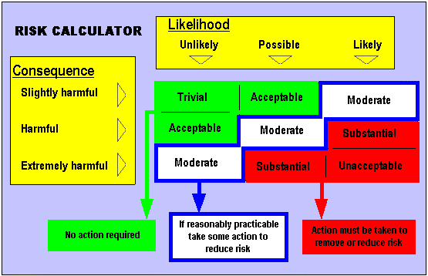
Date of Assessment: | Initially April 2011
Assessor Signature: | Peter Harris
Assessment Frequency: | Education Leeds - Annually or as circumstances change  Schools/Centres - before during and after activity.
Follow up Assessment Dates: | March 2012 | March 2013 | April 2014
Signed and accepted by Headteacher / Centre Manager:
Signed and Accepted by Chair of Governors:
IF YOU AMEND THE RISK ASSESSMENT YOU MUST RE EVALUATE THE RISK RATINGS - IF YOU DO NOT AMEND THEM, THEN YOU ARE AGREEING THAT YOU WILL APPLY ALL THE CONTROL MEASURES THAT ARE IDENTIFIED

Issues Raised by the EVC for Consideration / Addition to the Risk Assessment
Areas of Concern | Have these concerns been reflected in the Risk Assessment | Who has amended the Risk Assessment | If the Risk Assessment has not been amended please give reasons why

MANDATORY REQUIREMENTS  (NOT TO BE ALTERED) | Events / Circumstances that could increase risk | Other appropriate risk assessments to consider
- Supervisory ratios of 1:10 (Adults : Pupils).  - Parental consent to be obtained for this activity. | - Attendance of other parties of children  - Large numbers of people at the site  - Busy train

Hazard observed | Who may be harmed? | Risk rating before controls  Consequence x Likelihood = | Control measures | Risk rating after controls  Consequence x Likelihood = | Control measures by:  initial
Person being hit by train or falling onto track | Pupils, adults and other adult helpers | Substantial | - Appropriate supervision levels to be in place and strict supervision followed. The supervision ratio is a minimum of 1:10.  - Rules of behaviour to be clearly explained to pupils before they are allowed onto platform, in particular out of bounds areas and the need to stay away from platform edge and not run or push people on the platform.  - Group to be supervised when moving onto platform, and at all times on platform. No person to be within 2m of platform edge until train stopped in station  - If the waiting room at the station is open and not full, staff should keep the pupils in the waiting room until the train arrives. This is almost always possible at New Pudsey.  - Pupils to enter / exit carriages once train is stationary in single file led by adult & brought up at rear by adult. | Moderate | JH, GD and other adults
Staff / pupils getting lost / abducted | Pupils, staff and other adult helpers | Substantial | - Where possible, pupils should all be sat in the same carriage. Where this is not possible then there should be adequate supervision in each carriage, with at least one member of staff in each carriage.  - Pupils told not to open or close carriage doors. They should also be told not to open or lean out of windows.  - Where possible, pupils to be seated throughout whole of journey. If pupils need to leave their seats for any reason during the journey they must inform a supervising adult and go as a minimum in pairs, one pair at a time.  - Head counts carried out on entering train, during journey and at destination station as they leave the train.  - Every adult & child must be clear on the actions they should take the event of being left on train or platform. An emergency sticker or card with school name and contact details should be issued to children. All adults should have leader and other adult mobile numbers , as well as school. | Acceptable | JH, GD and other adults

School/Centre Identified Risks : -

Hazard observed | Who may be harmed? | Risk rating before controls  Consequence x Likelihood = | Control measures | Risk rating after controls  Consequence x Likelihood = | Control measures by:  Initial
Injury caused by having to stand due to lack of seats and sudden jolt | Pupils and staff | Moderate | All pupils to be told to hold onto something whilst train is in motion. Adults to check and remind.  Only short journeys to be taken in this way, e.g. Pudsey to Leeds  Avoid rush hour  Inform train company of intended travel and agree numbers | Acceptable | JH, GD and other adults  Janet Spencer
Being stuck due to getting off at wrong station! | The teacher responsible | You wouldn’t have thought so… | Tell them 1000 times Ribblehead NOT Horton in Ribblesdale | Acceptable | JH, GD and other adults

Please ensure the following people have been informed of the risk assessment by the most appropriate means: | Adults on visit Head Teacher Governors Parents Pupils EVC
Have employees been instructed to report newly identified hazards at post visit meeting? | Yes No | Details of newly identified hazards.

