SMS 3.4_4_7  School  Assessment  Number: |  | Blank Risk Assessment for Educational Visits
 |  | Assessment Title |  | Walking around Ribblehead on Y5 Resi
 |  | School / Centre : |  | Farsley Farfield Primary School
Visit details: Location: Yorkshire Dales, around Ribblehead Dates 19-23/5/2014

Year Group (s) : 5
 |  | Issued by: | C.Allen |  | Approved by: | A.Bradley | Issue Number: | 1/2004 | Sheet Number: | 1 of 2

Legislation / Information Source: | - Management of H & S at Work Regulations 1999  - Section 4, 5, 6 Handbook for Educational Visits |  |  |  |  | 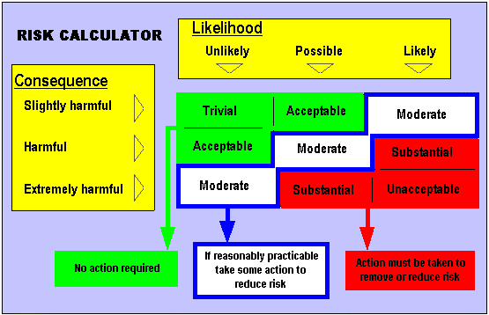
Date of Assessment: | Initailly March 2011 and on-going
Assessor Signature: | Peter Harris
Assessment Frequency: | Education Leeds - Annually or as circumstances change  Schools/Centres - before during and after activity.
Follow up Assessment Dates: | March 2012 | April 2013 | April 2014
Signed and accepted by Headteacher / Centre Manager:
Signed and Accepted by Chair of Governors:
IF YOU AMEND THE RISK ASSESSMENT YOU MUST RE EVALUATE THE RISK RATINGS - IF YOU DO NOT AMEND THEM, THEN YOU ARE AGREEING THAT YOU WILL APPLY ALL THE CONTROL MEASURES THAT ARE IDENTIFIED

Issues Raised by the EVC for Consideration / Addition to the Risk Assessment
Areas of Concern | Have these concerns been reflected in the Risk Assessment | Who has amended the Risk Assessment | If the Risk Assessment has not been amended please give reasons why

MANDATORY REQUIREMENTS  (NOT TO BE ALTERED) | Events / Circumstances that could increase risk | Other appropriate risk assessments to consider
- Supervisory ratios of 1:6  - Parental consent to be obtained for this activity. | Very bad weather

Hazard observed | Who may be harmed? | Risk rating before controls  Consequence x Likelihood = | Control measures | Risk rating after controls  Consequence x Likelihood = | Control measures by:  Initial
Unsuitable paths / Access Routes | Pupils, staff & other adult helpers | Substantial | - Activity Leader to make themselves aware of access requirements to the specific area of the walk prior to the walk  - Ensure all routes are on the rights of way or permission paths. If not then evidence should be obtained to show that landowners have given permission in advance for use of that property. | Acceptable | PH, JH, GD, LL, RH, LC
Slips, trips and falls | Pupils, staff and other helpers | Substantial | - Route chosen to avoid steep sloped / sheer drops.  - Staff to check that suitable footwear is worn before setting off on visit. – walking boots or wellies to be worn to give some ankle support and grip.  - First aid kit to be taken by person with suitable knowledge of how to use it.  - If visit includes entering a remote area then a qualified first aider is to be present: RH or LL  - Leader of the group should avoid where possible any obvious potential hazards or warn the group, e.g. steep slopes, fallen trees. | Acceptable | PH, JH, GD, LL, RH, LC
Being struck by traffic on the road | Pupils, staff & other adult helpers | Unacceptable | - Where there is no pavement, the group is to walk facing the oncoming traffic  - The group to walk in single file and keep well in to the right – adult at the front and adult to the back with others throughout the group. High visibility clothing and vests are recommended at least for all adults.  - All members to listen for approaching traffic and inform the rest of the group if they hear anything.  - All children to be briefed on the strict guidelines on behaviour on the roads prior to the walk.  None of the proposed walks involves significant road walking. Waterfall walk includes one single track road to cross and a few yards in a car park. River study includes few hundred yards on agricultural single track road. | Acceptable | PH, JH, GD, LL, RH, LC
Farmyards  (Dogs, moving machinery, slurry tanks, farmyard animals) | Pupils, staff and other adult helpers | Substantial | - Activity Leader to ensure route is actually meant to go through a farmyard before walk takes place. If this is the case group to be briefed that they should not touch machinery, enter farm buildings, climb on fences etc. They should be strictly supervised whilst passing through farmyard as quickly & quietly as possible.  Only farm yard is at start/end of Night Walk and it is adjacent to walk not the middle of it. | Acceptable | PH, JH, GD, LL, RH, LC
Falls from Walls, fences, gates and stiles | Pupils, staff and other adult helpers | Substantial | - Adults to ensure no member of the group climbs onto gates or walls except stiles.  - Ensure that children use stiles in the correct fashion.  - It must be remembered that the use of stiles can cause considerable delay to the party.  - Ensure that the group is not split up. Leaders and adults must ensure all gates are closed behind them. | Acceptable | PH, JH, GD, LL, RH, LC

Hazard observed | Who may be harmed? | Risk rating before controls  Consequence x Likelihood = | Control measures | Risk rating after controls  Consequence x Likelihood = | Control measures by:  Initial
Hypothermia | Pupils, staff and other adult helpers | Substantial | - Leader trained to be aware of all the signs and symptoms and how to deal with them if they arise.  - All participants to be adequately clothed (hats, gloves, scarves, and waterproofs) – this must be checked before setting off on visit.  - Obtain a weather forecast. If it is likely for extremely wet or cold conditions, or any of the group is not suitable clothed, then make alternative arrangements. Unlikely to be excessively cold in mid-May.  - Spare dry clothes to be kept at base or school or carried on long or full day walks. | Acceptable | PH, JH, GD, LL, RH, LC
Sunstroke, Heat Exhaustion | Pupils, staff and other adult helpers | Substantial | - Leader trained to be aware of all signs and symptoms and how to deal with them if they arise.  - Activity leader must ensure that participants are suitably dressed with sun hats and loose clothing to cover unprotected skin. Sun cream to be applied to exposed skin and cold drinks to be available.  - Alternative plans should be made if it is felt the weather is too hot and or too sunny. | Acceptable | PH, JH, GD, LL, RH, LC
Getting Lost | Pupils, staff and other adult helpers | Unacceptable | - Activity leader to have prior knowledge of route to be taken. Other adults and children to be briefed using the map. Photo route card produced for evening walk.  - Activity Leader to be conversant with the use of a map and compass, which they will regularly check on route to avoid getting lost if not following well marked paths such as on part of the evening walk Mon/Wed. There is only one section of the Mon/Wed evening walk that is not on obvious path (although part of the Ribble Way): 787 787 to 789 784 but this is enclosed by a wall so you can’t leave the area without finding the correct gate/stile).  - After some difficulties in 2012, the leader of the night walk heading off from Gearstones should leave some minitorches (science cupboard) on wall tops to guide the return. Recommend 10.  - Leader needs ability to correct any errors made in navigation and return the group to planned route or find an alternative safe route.  - If the party is to split, adults in charge of each group will need the above skills.  - The whole party needs to be informed of intended route and have access to maps. At least one person to have a whistle. Each person needs to be made aware of what to do in the event of getting lost.  - Adults to have designated groups of children and carry out regular head counts. | Acceptable | PH, JH, GD, LL, RH, LC
Remote Area | Pupils, staff and other adult helpers | Substantial | - Adequate first aid kit taken by adult who has knowledge on how to use it.  - Adult in party to have First Aid qualification (First Aid at Work)  - Party to have knowledge of how to contact emergency services and means to do so. | Acceptable | RH, LL
Animals and insect bites | Pupils, staff and other adult helpers | Substantial | - Avoid animals where possible  - Ensure that insect repellent is carried and used where appropriate. | Acceptable | PH, JH, GD, LL, RH, LC

School/Centre Identified Risks : -

Hazard observed | Who may be harmed? | Risk rating before controls  Consequence x Likelihood = | Control measures (in addition to measures above) | Risk rating after controls  Consequence x Likelihood = | Control measures by:  Initial
Walk 1  Waterfall Walk at Ingleton  Fall into water or off a drop | All | Substantial | Use of established paths at a designated tourist site  Group briefed of route and particular hazards  Good supervision of children with 1:6 adult ratio in groups of 12  Children not allowed to run off ahead out of sight or dawdle behind  No paddling other than a very safe and shallow area determined by group leader with high adult supervision inc top and bottom of permitted area. | Acceptable | PH
Walk 2  Evening Walk along Ribble Way  Getting lost  Hit by falling masonry | All | Moderate | - After some difficulties in 2012, the leader of the night walk heading off from Gearstones should leave some minitorches (science cupboard) on wall tops to guide the return. Recommend 10.  Walk pre-visited March 2011  Set off by 8.15 (adult 1hr 15 mins on pre-visit with note taking and photographs therefore should be back by 10-10.30pm) Take footbridge at start of walk rather than ford.  There is only one section of this evening walk that is not on obvious path (although part of the Ribble Way): 787 787 to 789 784 but this is enclosed by a wall so you can’t leave the area without finding the correct gate/stile). Orientate map prior to beginning this section.  Start of ‘tricky section’ (from other side):  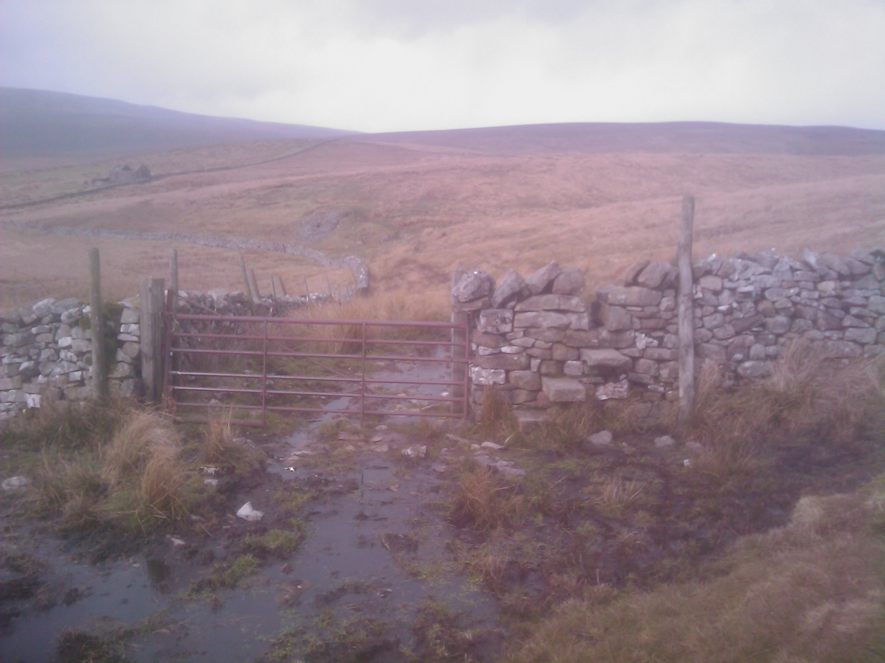  End of ‘tricky section’:  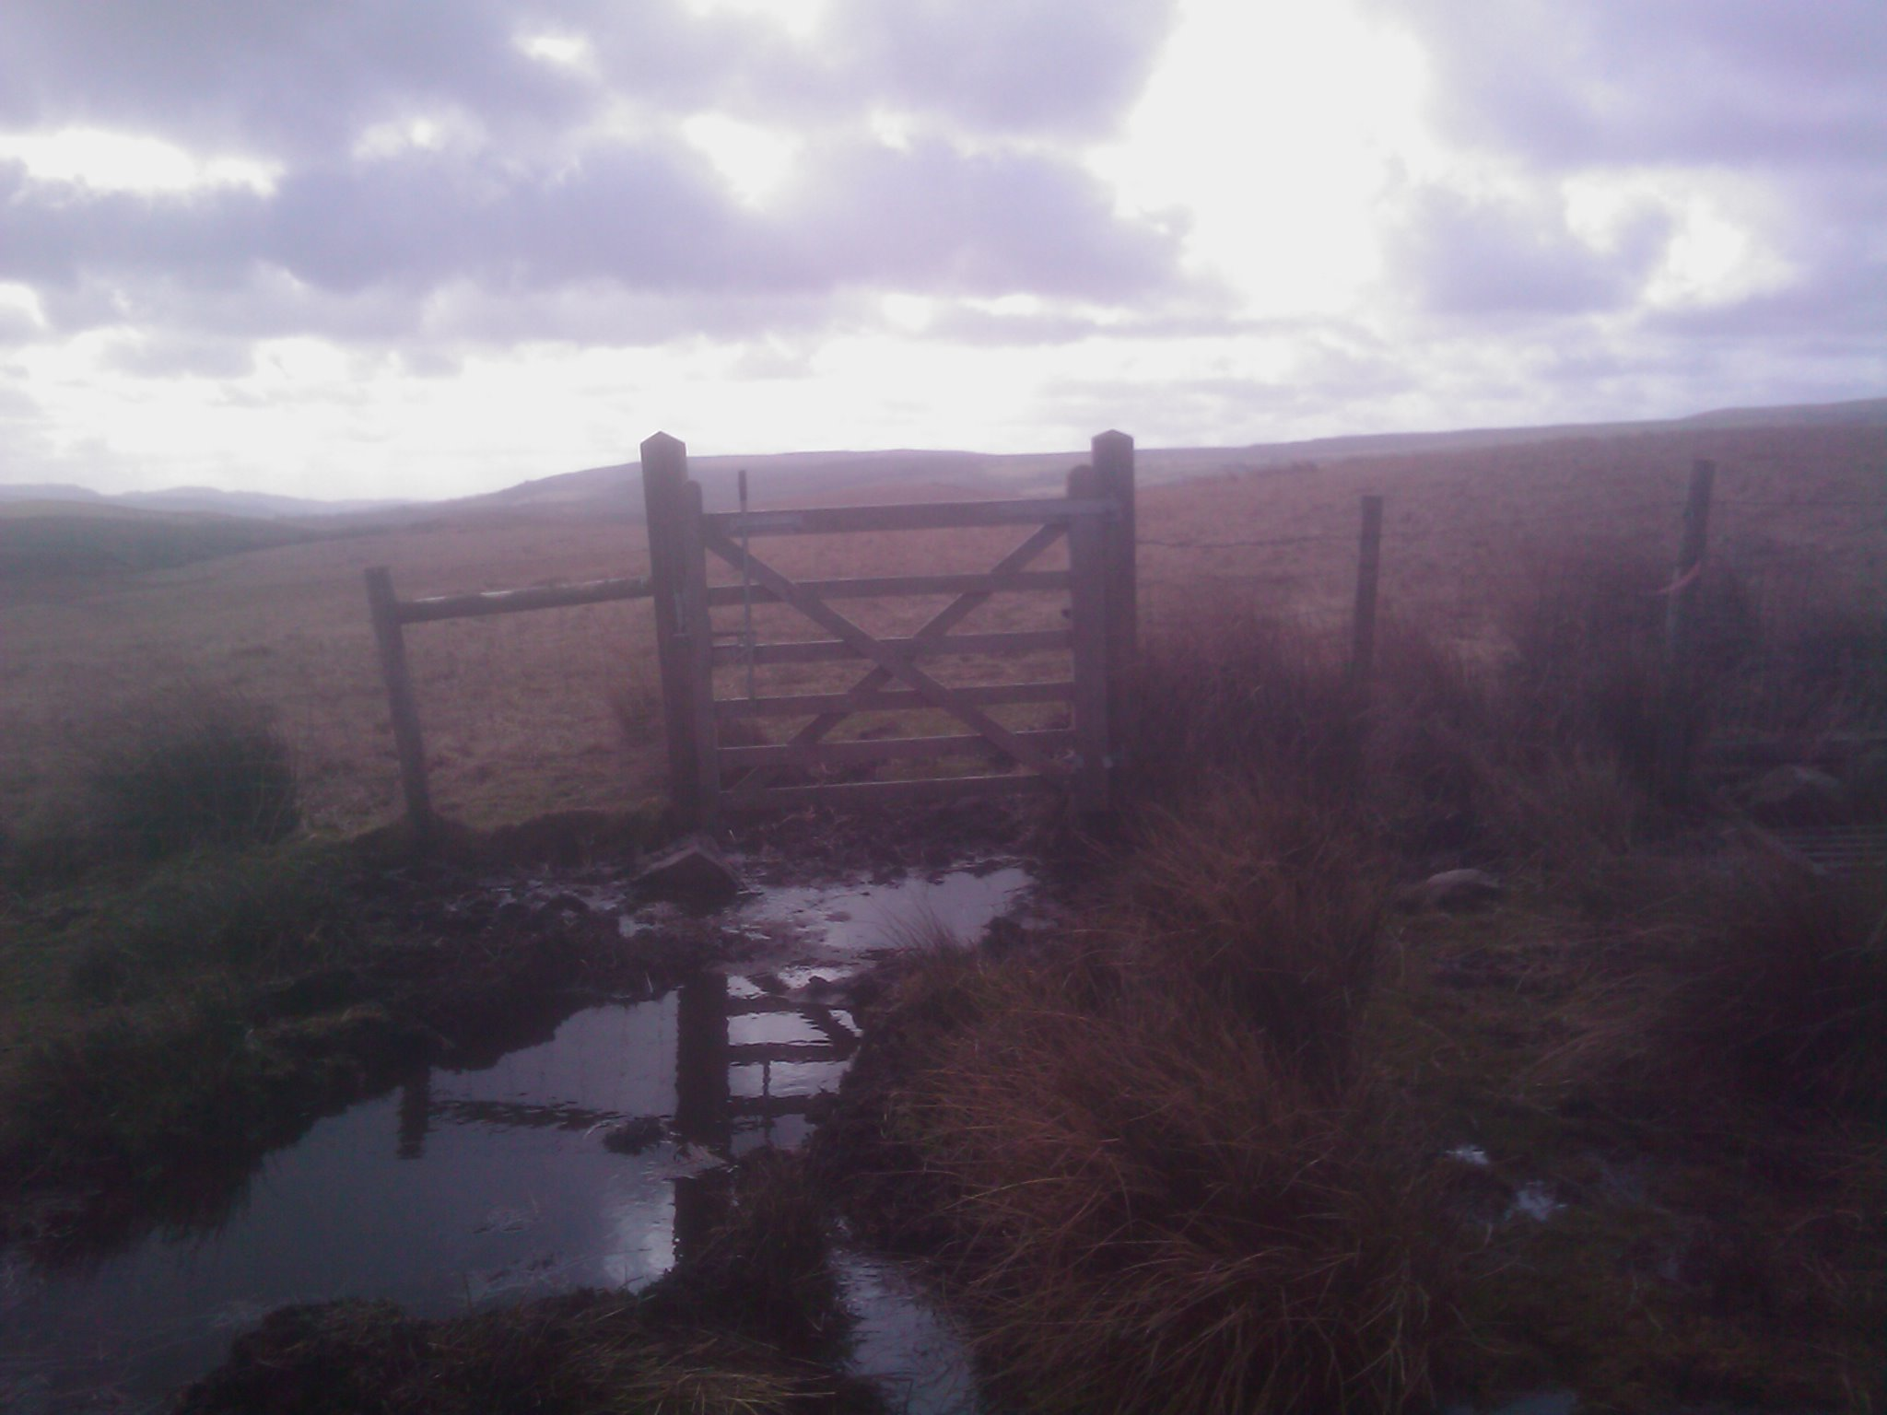  Adults to take torches as well as usual safety equipment e.g, first aid kits, whistle. Pupils to carry waterproofs and warm clothes in day sacks.  Pupils not to enter any dilapilated buildings on route:  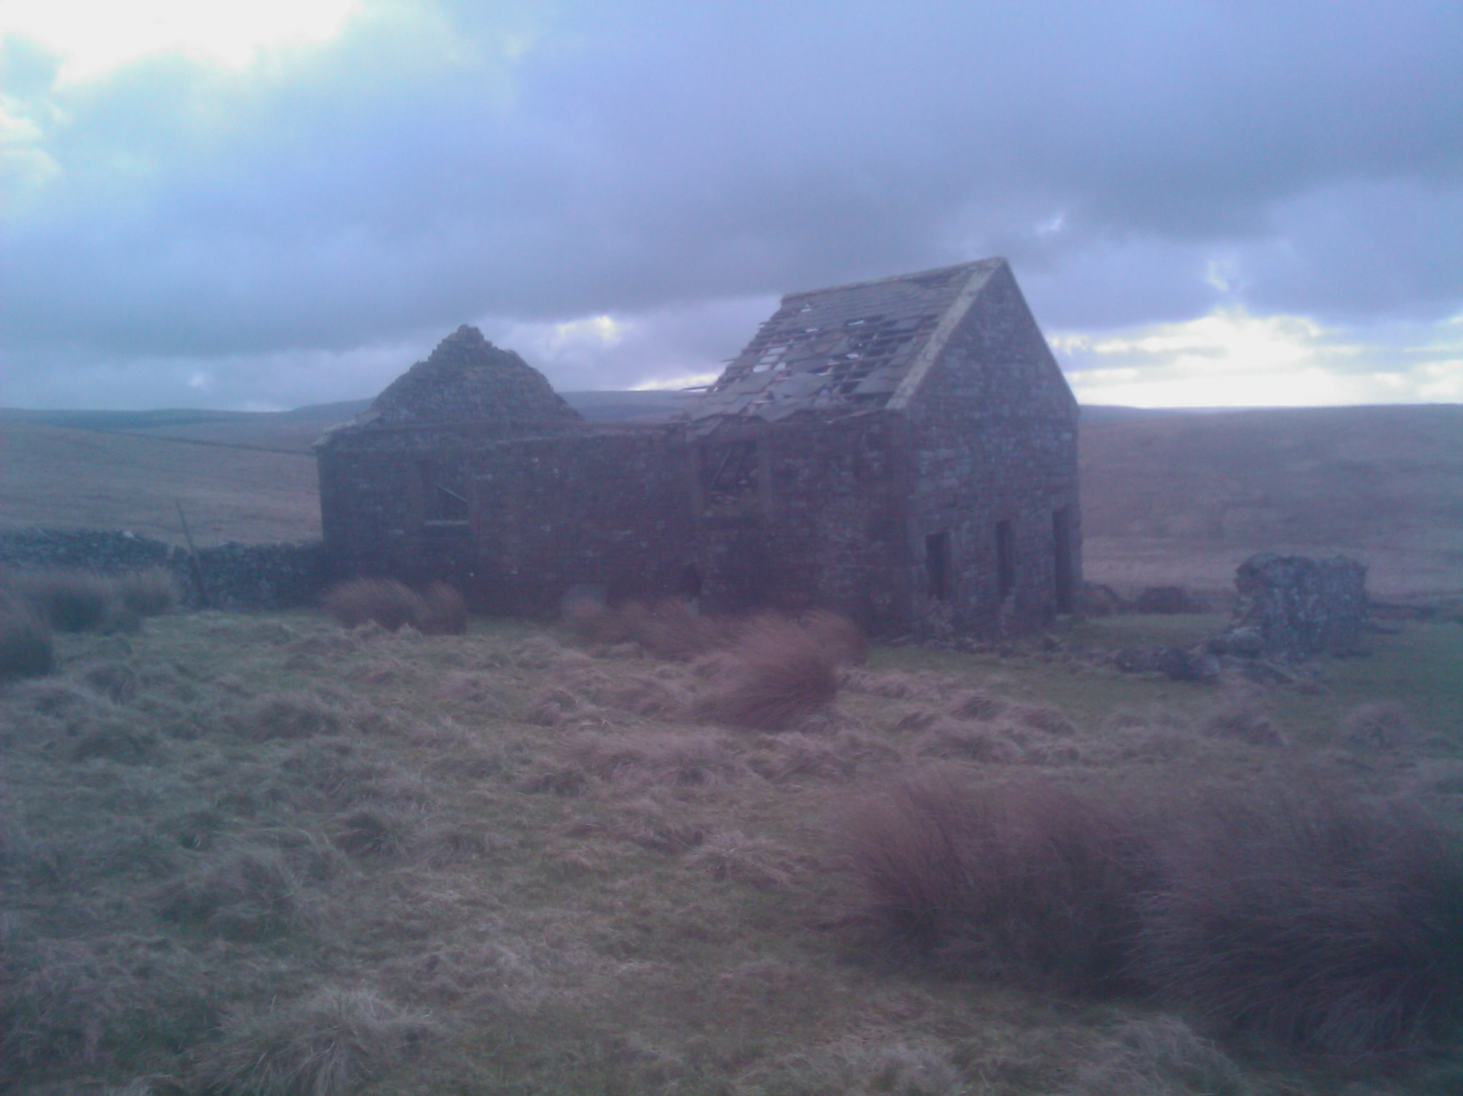  Pupils not to be allowed too close to potential hazard at God’s Bridge 798 776 (risk of fall into water and hole under bridge - see below)  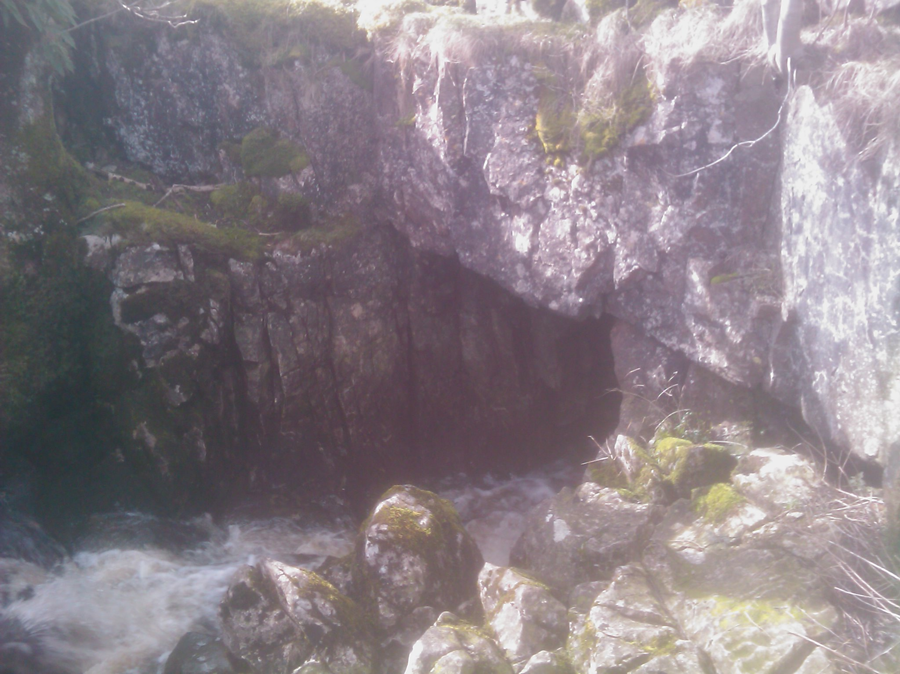 | Acceptable | PH

Walk 3  River Study  Winterscales Beck | All | Moderate | Pupils to be under close supervision when exploring the area marked ‘Caves’ near Philpinn Lane. Pupils can peer safely into the horizontal cave opening and clamber over rocks.  Teacher to make judgement as regards flow levels of Beck before determining how close to the beck the children can walk. If levels are low, then children in wellies can walk along the beck looking for resurgences (Where a spring of a river appears above ground after the river having been flowing underground. Above the spring is Limestone and below is impermeable rock) and silt deposits.  The sides of the beck are quite steep in places. This should be manageable with care in dry conditions. May need to stick to route of path more closely in wet weather.  Be aware of vehicles on agricultural road/track. In 2014, we will have to park a little further from the start of the walk, so more care needed on this track.  If there are cattle in a field, walk as a tighter group and ensure that group does not come between a mother and its calf.  Do not deviate from path as you cross Gunnerfleet Farm. | Acceptable | PH

Please ensure the following people have been informed of the risk assessment by the most appropriate means: | Adults on visit Head Teacher Governors Parents Pupils EVC
Have employees been instructed to report newly identified hazards at post visit meeting? | Yes No | Details of newly identified hazards.

Notes for 2014:

Additional considerations due to participants. Ensure that medication is taken for IL and that account is taken of MC’s walking restrictions (see separate document).

